Exam of Digital Communications
a.a. 2020-2021
Feb. 02, 2021

Exercise #1

A message signal m (t) = cos 2000πt + 2 cos 4000πt modulates the carrier c (t) = 100 cos2πfct, where fc = 1 MHz.

- Sketch the spectrum of the SSB+ modulated signal
- Find the complex envelope for the modulated signal

Exercise #2
A message signal m(t) is transmitted by binary PCM. Let the signal to-quantization noise (SQNR) required be at least 50 dB. Determine the minimum number of bit required to encode each sample, assuming that m(t) is sinusoidal. With this value of quantization levels, determine the SQNR.

NMl

Exercise #3

In an additive white Gaussian noise channel with noise power spectral density of N0/2, two bits are transmitted by

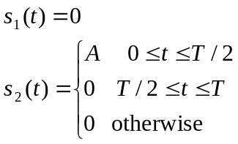

The two messages are transmitted with a priori probabilities p and (1-p), respectively.

- Determine the average energy transmitted per bit 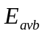
- Determine the optimum threshold
- Determine the structure of the optimal receiver (including the detector after the sampler)
- Determine the probability of error in case p=(1-p)=0.5.

Exercise #4

If the maximum BER is 10(-4) and SNR is 12dB, with 8 psk which constellations guarantees the maximum bit rate? What is the maximum theoretical bit rate in case with no ISI if the bandwidth available is 3kHz?

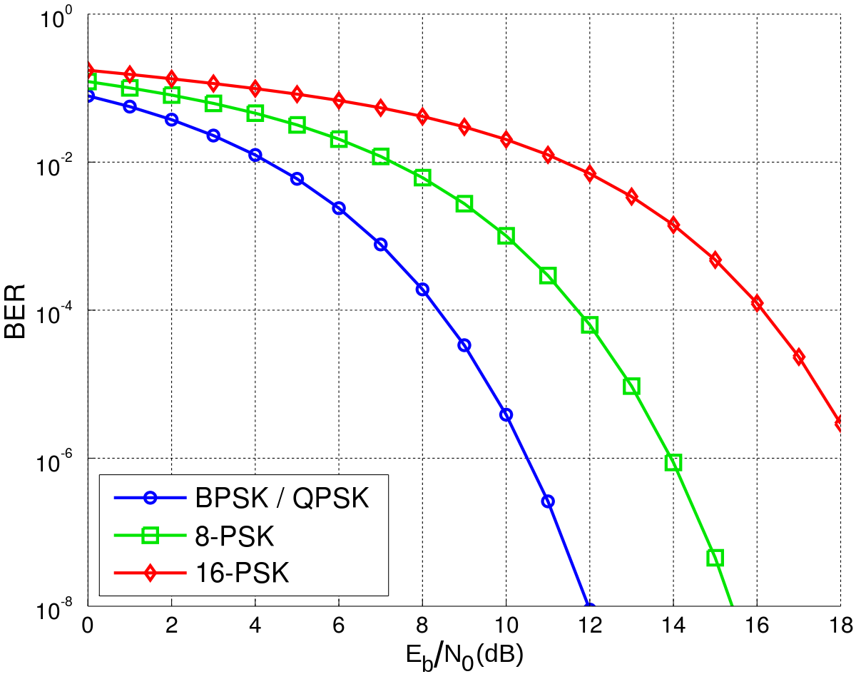

Exercise #5
Let us consider two channels that are modeled as linear filter and AWGN. The impulse responses of the two channels are drawn below:

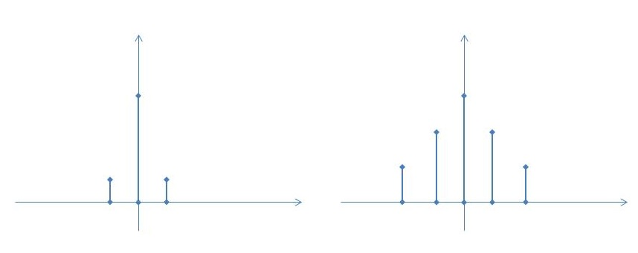
- (b)

- In which case is more important to use an equalizer at the receiver?
- When the equalizer is not used, how do you expect that the BER curve look like?

- In case of low signal to noise ratio would you use a zero forcing or an mmse equalizer?

﻿

a) When compared with impulse response of (b),impulse response of (a) contains less number of samples,even though the transmission channel bandwidth is low all the samples can be received by the reciever such that information at both tramitter and reciever will match. Hence it is more important to use equalizer at the reciever in (b) as the signal gets dispersed(distortrd) and causes Inter symbol Interference distortion.
b) If we don't use equalizer at the reciever the BER curve will be shifted downwards hence curve is not flat and linear so the information at transmitter will not match with receiver as the Signal to noise ratio will be very low due to distortion caused by Inter symbol Interference ISI.
c) In case of low signal to noise ratio which means noise is very high it is better to use Minimum mean square error algorithm(MMSE) because zero forcing technique is used in noise free state and it is used when signal to noise ratio is significant. But when SNR is Low it is better to use MMSE algorithm technique at the reciever to eliminate Inter symbol Interference ISI.

If compared to impulse response (b),impulse response (a) contains fewer samples, even though the transmission channel bandwidth is low, all the samples can be received by the receiver so that information is matched between transmitter and receiver. It is therefore more important to use equalizers at the receiver in (b) since the signal gets dispersed and causes interference.

